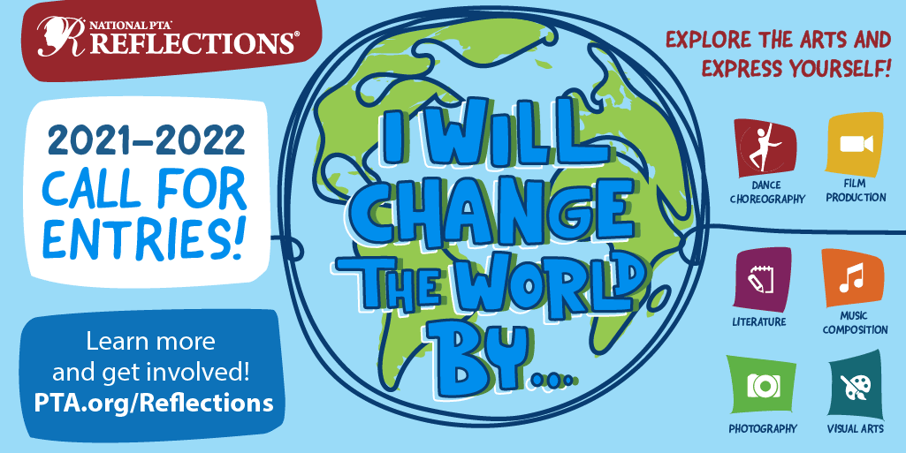

What is the Reflections Program??

National PTA's Reflections program provides opportunities for recognition and access to the arts which boost student confidence and success in the arts and in life.

Each year, over 300,000 students in Pre-K through Grade 12 create original works of art in response to a student-selected theme. This 50+ year-old program helps them explore their own thoughts, feelings and ideas, develop artistic literacy, increase confidence and find a love for learning that will help them become more successful in school and in life.

The 2021–2022 Reflections theme is **I Will Change the World By…**

Students submit their completed works of art in one or all of the available arts categories: Dance Choreography, Film Production, Literature, Music Composition, Photography, Visual Arts.

Arizona PTA will communicate deadlines and resources via social media and newsletters.

Where do I start??

1. Get familiar with theme and the categories and recruit a team and a set of judges (August)
2. Promote your program, partner with teachers to see if they can make it part of their curriculum and build the buzz (mid August to early September)
3. Officially kick off the program, highly recommended you start during National Arts in Education Week (Sept. 12 –18, 2021)
4. Host an event during National Arts and Humanities Month (October) offer time, space and materials for students to participate in the arts.
5. Start collecting the submissions and do the judging (Mid October-Early November)
6. Celebrate your school winners and send them on to the Arizona State PTA by Friday 12/3/2021.